Medimesh Clinic Intelligence Platform
Pilot Implementation Proposal — SN Karau & Associates Clinic

- Executive Summary
Medimesh is a modular, open-source–powered platform that unifies electronic health records (EHR), operational workflows, and real-time analytics for small-to-medium clinics.
This proposal details the minimum viable product (MVP) to be deployed at SN Karau & Associates Clinic as the reference implementation before scaling to additional facilities.
- Background & Problem Statement
Level 1 and Level 2 clinics across Kenya still rely on battered patient registers, improvised notebooks, and disconnected Excel sheets. Every manual hand-off delays diagnosis, drags billing across days, and invites transcription errors that can threaten patient safety. When these facilities look to digitise, they are greeted by enterprise EHR suites built—and priced—for tertiary hospitals: steep annual licences, complex deployment contracts, and proprietary clouds that place their data out of reach. Medimesh was designed to close this gap. The platform runs comfortably on a modest on-prem server or as a secure, Kenyan-hosted cloud instance, and its offline-capable mobile app turns the Android phones and tablets clinicians already carry into point-of-care recorders. Notes, vitals, and even images sync automatically once connectivity returns, giving caregivers real-time visibility without demanding constant Internet. All information remains encrypted and fully compliant with the Kenya Data Protection Act 2019, while Medimesh’s open APIs are already mapped to the upcoming SHIF e-claims specification—helping small clinics claim reimbursements faster without surrendering ownership of their data.
- Vision
“One lightweight mesh for every clinic—secure, interoperable, and insight-driven.”
- Objectives & Success Metrics
Objective | KPI | Target
Capture every patient touch-point digitally | % of encounters recorded in Medimesh (mobile or desktop) | ≥ 95 % by end of month 3
Accelerate cash flow from care to cash | Median hours from encounter → claim submission → payment | ≤ 24 h by month 4
Empower frontline decisions with insight | Clinical staff logging into dashboards weekly | ≥ 85 % adoption by month 4
Assure data quality & compliance | % of records passing validation & audit checks | ≥ 98 % sustained
Maintain high system availability | Uptime during clinic hours | ≥ 99 % rolling monthly

- Product Scope
Unlike monolithic hospital suites, Medimesh is carved into small, interoperable services that clinics can adopt incrementally. The platform’s spine is a set of core back-end modules, wrapped by a lightweight, offline-capable front-end that runs on any browser or Android handset.
  - Core Modules
- Patient EHR — Demographics, vitals, clinical notes, diagnostics, imaging links (DICOM). A longitudinal, FHIR-compatible record that accompanies each patient from triage to discharge. Structured forms capture demographics, vitals, SOAP notes, prescriptions and diagnostics, while radiology is referenced through secure DICOM links so images stream instantly without bloating the database.
- Workflow & Scheduling — Appointments, triage queue, task lists. An elastic queue replaces corridor guess-work: colour-coded cards show who is waiting, for what service, and for how long. A drag-and-drop calendar powers appointment booking, procedure slots, and outreach camps.
- Billing & Insurance — Tariff management, SHIF e-claim export, M-Pesa/Bank integrations. Tariffs live in one authoritative table and auto-apply clinic-specific mark-ups. When an encounter closes, Medimesh assembles an electronic claim that meets the new Social Health Insurance Fund (SHIF) XML schema. One click posts it, and M-Pesa STK push or bank APIs return receipts directly into the ledger.
- Document & Imaging Vault — X-ray, lab results, consent forms stored in S3-compatible MinIO. Behind the scenes MinIO provides S3-compatible object storage with bucket-level encryption. A lab PDF, a signed consent form, or a 25 MB chest X-ray are each a URI away from the chart and load on demand.
- Analytics & BI — Pre-built KPI dashboards plus ad-hoc exploration in Superset. Every event streams through Redis into an Apache Iceberg lakehouse. Superset ships ready-made dashboards—patient throughput, revenue curves, lab turnaround—while analysts can spin up ad-hoc SQL without touching production data.
- Admin & RBAC — Fine-grained roles (doctor, nurse, lab, cashier, admin). Keycloak issues short-lived tokens scoped more finely than a duty roster. A cashier sees only invoices; a locum doctor edits charts but cannot export; every action lands in an immutable audit trail.
- Integration APIs — FHIR-compatible REST/GraphQL, Webhooks. REST and GraphQL endpoints mirror underlying FHIR resources, while Webhooks publish real‑time events (patient.created, invoice.paid) so external labs, DHIS2 gateways, or mobile apps can subscribe.
  - Front-end Experience
The client is a React Progressive Web App (PWA) that feels as quick and familiar as WhatsApp while remaining robust on a spotty 5 Mbps rural link.
- Mobile-first design: Finger-friendly buttons, dark-mode for night shifts, and adaptive layouts that stretch gracefully onto 14-inch reception laptops.
- Offline-first workflow: Data is cached locally with IndexedDB; clinicians continue charting during outages and a subtle badge shows sync status once connectivity resumes.
- Smart forms: Conditional questions surface only when relevant, reducing keystrokes by up to 40 %. Autocomplete leverages a local drug dictionary so “amoxicillin” is never mistyped.
- Patient search everywhere: A global search bar, powered by fuzzy matching, brings any chart forward in under 300 ms.
- Accessibility & localization: WCAG AA colour contrast, English/Swahili toggles, and voice-to-text notes for clinicians who prefer dictation.
Whether clinics choose the on-prem TrueNAS node or Medimesh’s secure Kenyan cloud, the experience is identical—allowing facilities to start on shared infrastructure today and transition to local hardware tomorrow, without vendor lock-in.
  - Out-of-Scope (Phase II+)
- Pharmacy inventory.
- Tele-medicine video modules.
- AI-assisted diagnostics.

- Target Users & Personas
Persona | Key Goals | Pain Points
Doctor | Quick patient chart access | Paper files lost, duplication
Nurse | Fast triage & vitals capture | Re-entering data into Excel
Accountant | Same-day billing | Manual SHIF forms
Administrator | Compliance & uptime | Costly proprietary EHR

- Functional Specifications
Medimesh adheres to five guiding capabilities that keep frontline realities—spotty bandwidth, lean staffing, and strict regulation—at the heart of its design.
- Search-first UI with global patient lookup. A universal search bar crowns every screen, accepting a patient’s name, phone number, national ID, or medical-record number and returning results in well under 300 milliseconds. Autocomplete with fuzzy logic mops up spelling errors, while coloured status chips reveal at a glance whether the patient is checked-in, awaiting triage, or overdue for review.
- Offline-first Progressive Web Application (PWA): local cache for intermittent Internet. Internet drops should not derail care. The client installs like a native app on Android phones, entry-level tablets, or desktop browsers, storing encrypted data locally via IndexedDB. Clinicians keep charting; once even a trickle of connectivity returns, Medimesh syncs the delta in the background, merging edits safely and surfacing any conflicts for human review.
- Template-driven notes (SOAP, LOINC codes): Charting follows the familiar Subjective-Objective-Assessment-Plan (SOAP) framework, but each field is bound to a code from the Logical Observation Identifiers Names and Codes (LOINC) standard. This transforms narrative entries into structured data ready for decision support engines and national surveillance feeds. A drag-and-drop designer lets department heads tweak templates—e.g., dental girds, obstetric scores—without writing code.
- Granular audit trail on every update: Every create, read, update, and delete operation fires an event that captures the acting user, timestamp, endpoint, and a cryptographic hash of the before-and-after payload. These immutable logs reside in a Write-Once-Read-Many (WORM) dataset on Zettabyte File System (ZFS), satisfying the evidentiary bar of the Kenya Data Protection Act 2019 and, by extension, Health Insurance Portability and Accountability Act (HIPAA) requirements should the clinic ever expand to international research collaborations.
- Multi-tenant mode flagged off until Phase III. The pilot will run in single-clinic mode for operational simplicity, yet the codebase already prefixes every table with a tenant identifier, and JSON Web Tokens (JWTs) carry a tenant claim. Flipping the feature flag in Phase III will allow many facilities to co-exist on a single cloud cluster—each seeing only its own data—opening the door to group purchasing power and shared analytics.

- Non-Functional Requirements
Category | Requirement
Performance | ≤ 300 ms median API latency, 100 concurrent users
Availability | 99.5 % (single-site), 24/7 support SLA
Security | AES-256 at rest, TLS 1.3 in transit, OWASP Top-10 mitigations
Compliance | Kenya DPA 2019, MOH EMR standards, HIPAA parity
Scalability | Linear scale to 10 clinics (Phase III)
Observability | Prometheus metrics, Grafana dashboards, Loki logs

- Technical Architecture
  - Logical View
(See appendix A for full draw.io code)
[React PWA] ←→ [API Gateway: Apache APISIX] ←→ [Microservices (K3s)]
├── Patient-svc (FastAPI+SQLModel)
├── Billing-svc (FastAPI)
├── Analytics-svc (Flask/Superset)
└── Auth-svc (Keycloak)

[Data Layer on TrueNAS SCALE]
├── PostgreSQL 15 (clinical OLTP)
├── Apache Iceberg (analytics lakehouse)
├── MinIO (S3 object store)
└── Redis (caching, pub/sub)

  - Deployment Topology
- Single TrueNAS SCALE node (128 GB RAM, 16-core CPU, 40 TB ZFS). At the core sits a 4U chassis equipped with an AMD EPYC 16-core processor and 128 gigabytes of error-correcting memory. Eight enterprise 6 terabyte hard drives are arranged in a ZFS RAID-Z2 pool—tolerant of two simultaneous disk failures—delivering roughly 40 terabytes of usable capacity. Two one-terabyte NVMe solid-state drives act as a special metadata (SLOG) and read cache (L2ARC), accelerating small random I/O typical of database workloads. TrueNAS SCALE brings Linux-native containers, ZFS snapshots, and intuitive web management under one roof, allowing the clinic’s IT technician to monitor disks, temperatures, and SMART alerts without specialised training.
- K3s cluster running on bare-metal with Longhorn CSI. Rather than scattering workloads across many small machines, we consolidate them on the TrueNAS host and let K3s—a stripped-down, certified Kubernetes distribution—provide logical isolation between microservices. Should future growth demand more horsepower, an additional worker node can join the cluster in minutes, and the existing Persistent Volumes will simply migrate thanks to the storage layer described next. Longhorn turns ZFS datasets into highly available block devices for Kubernetes. Each volume is snapshot-aware; if a user accidentally deletes records or a ransomware attack strikes, we can roll the volume back to any point-in-time snapshot in seconds without taking the application offline.
- Traefik ingress, cert-manager for Let’s Encrypt. All external traffic enters through Traefik, which watches Kubernetes for new services and routes requests accordingly. Cert-manager plugs into Traefik to obtain and refresh Transport Layer Security (TLS) certificates from Let’s Encrypt, ensuring every dashboard, mobile API call, or webhook connection is encrypted end-to-end without manual certificate juggling
- Air-gapped backup station replicates ZFS snapshots nightly. A fanless mini-PC equipped with a pair of 12 terabyte drives sits in a locked cabinet, physically disconnected from both the Internet and regular clinic network segments. Every night at 02:00 a cron job on the TrueNAS host executes zfs send | ssh over a dedicated 2.5 gigabit direct-attach link, pushing incremental snapshots to the backup appliance. Once a week the most recent backup drive is swapped off-site. Because the backup server never initiates outbound connections—and accepts data only from the hardened TrueNAS IP—it remains insulated from intrusion attempts that target production systems.
This topology keeps capital expenditure low (one main server plus one low-cost backup box) yet affords data integrity, encrypted transport, rapid recovery, and a clear path to horizontal scale without forklift upgrades.

  - Data Flow
Care data moves through the platform in a fast, traceable pipeline that separates transaction processing from analytics so neither competes for resources.
- Point‑of‑care capture → Clinical microservice. The moment a clinician hits “Save & Close” on the Progressive Web App, the browser sends a JSON payload over the encrypted API Gateway to patient‑service, a FastAPI container that writes the encounter to the primary PostgreSQL database and instantly confirms success back to the user (< 200 milliseconds). At the same moment the microservice emits a domain event—encounter.completed—onto a Redis Streams channel.
- Event published to Redis → analytics-svc ETL via Apache Airflow DAG. An Apache Airflow Directed Acyclic Graph (DAG) listens to that Redis channel. Every five seconds it batches new events, fetches the associated clinical rows, enriches them with physician and tariff metadata, then writes them into an Apache Iceberg table partitioned by encounter_date. Airflow also computes incremental facts such as average waiting time and outstanding claim value, pushing these aggregates into separate Iceberg tables. Because the operation is append-only and uses Iceberg’s hidden partitioning, the query engine never has to scan more than the most recent partitions, keeping analytics brisk even as data grows.
- Lakehouse → Interactive dashboards. Superset, pointed at the Iceberg catalog through a lightweight JDBC/Arrow connector, exposes real time charts to clinicians and management. Median triage time refreshes every minute; month to date revenue recalculates right after each claim posts. Because analytics never touches the transactional PostgreSQL instance, the clinic can run complex cohort analyses during business hours without slowing down front desk operations.
This loosely coupled stream architecture means Medimesh can ingest thousands of events per second on minimal hardware, recover effortlessly (Airflow replays any missed Redis offsets), and scale horizontally—simply by adding another analytics worker—without redesigning the pipeline.
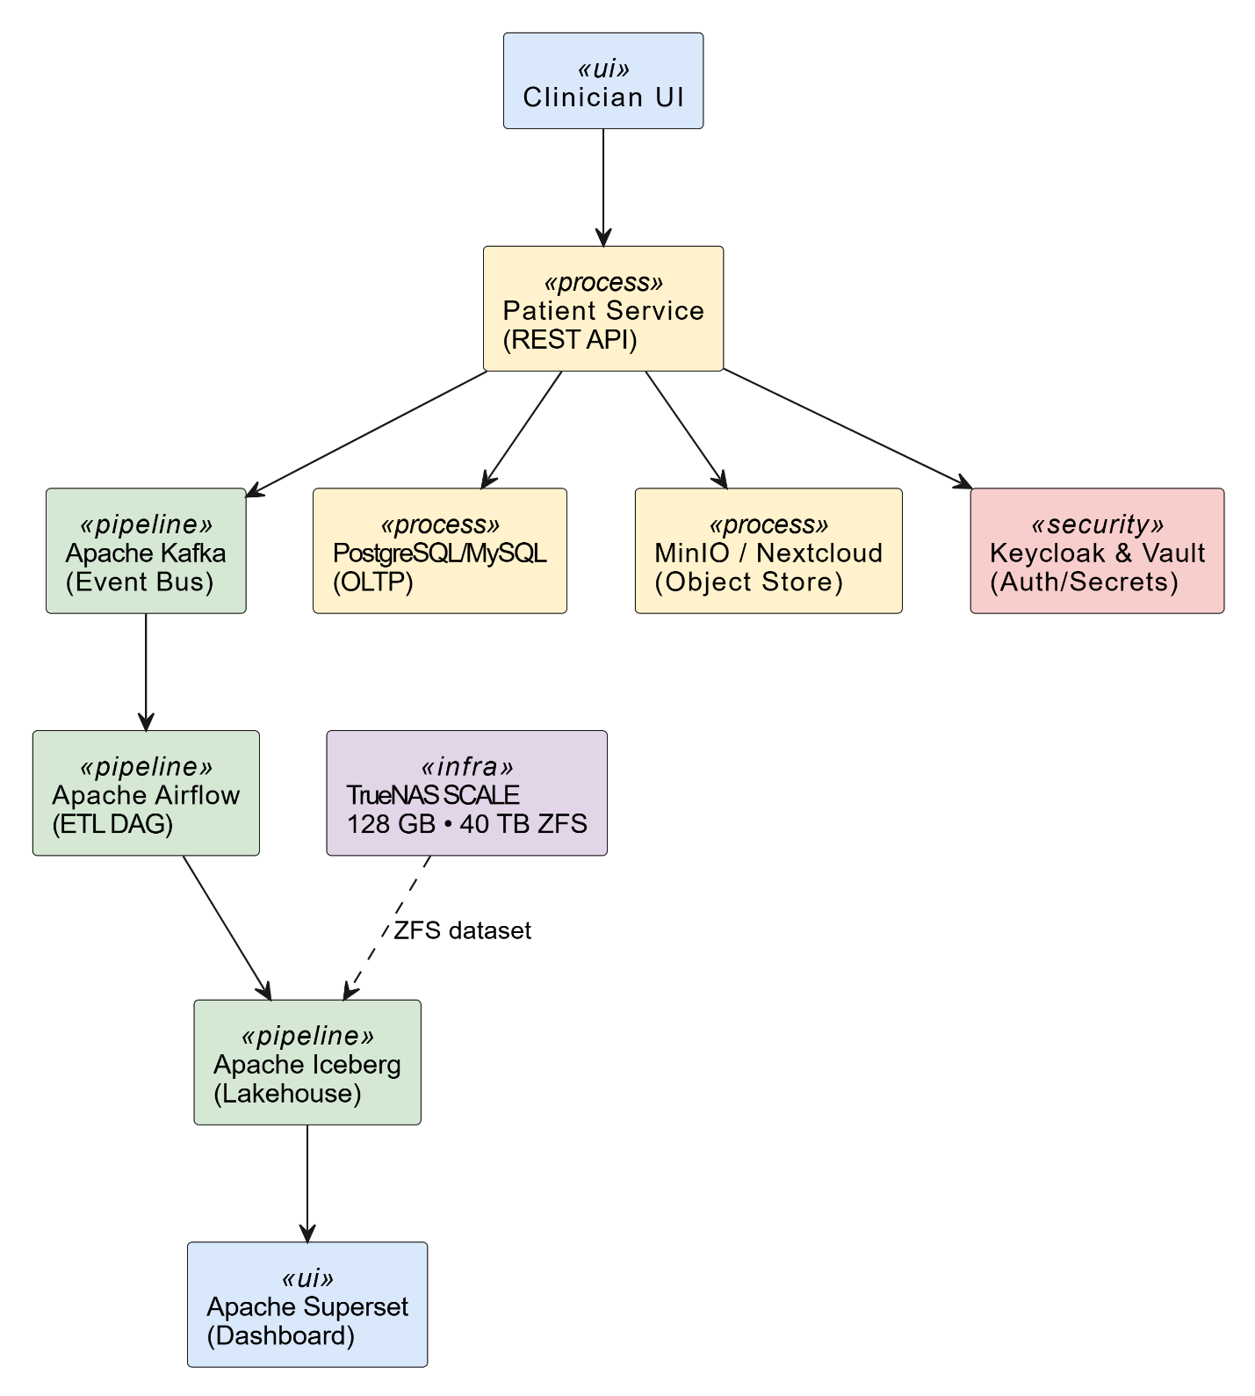
Fig. 1: Basic data flow
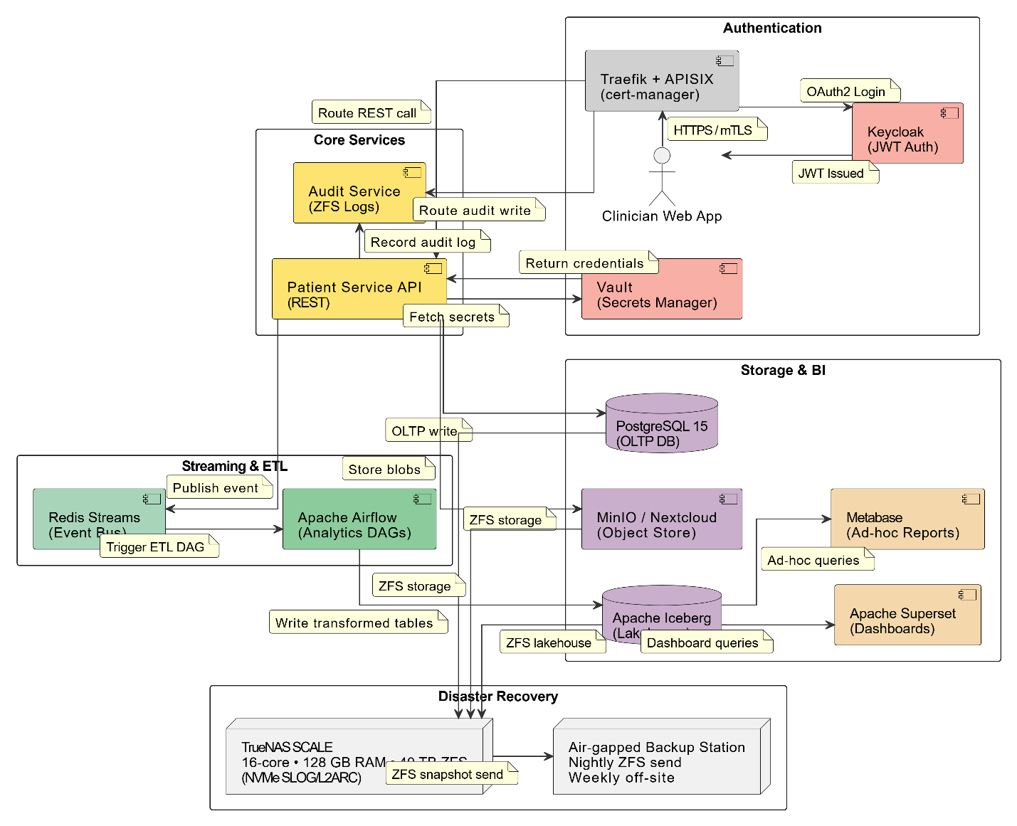
Fig. 2: Complete data flow
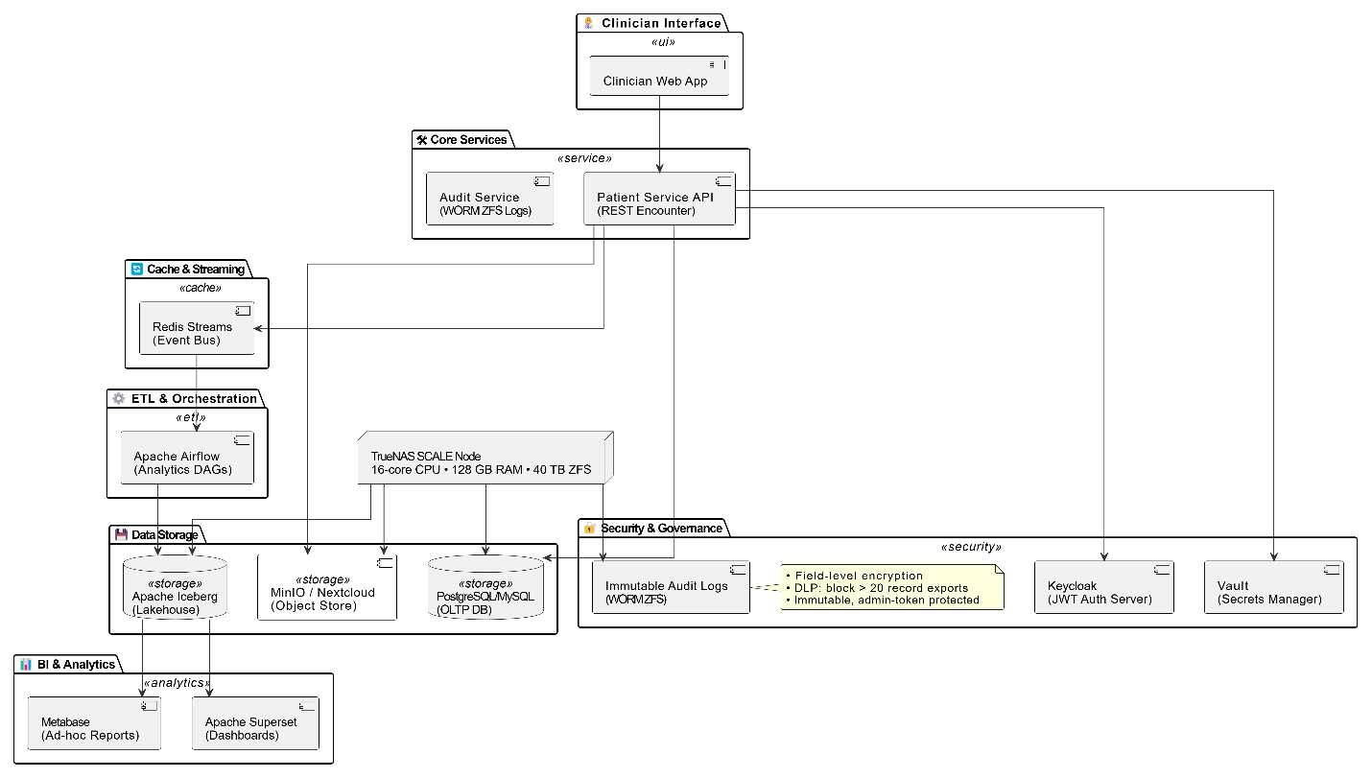
Fig. 3: Data architecture

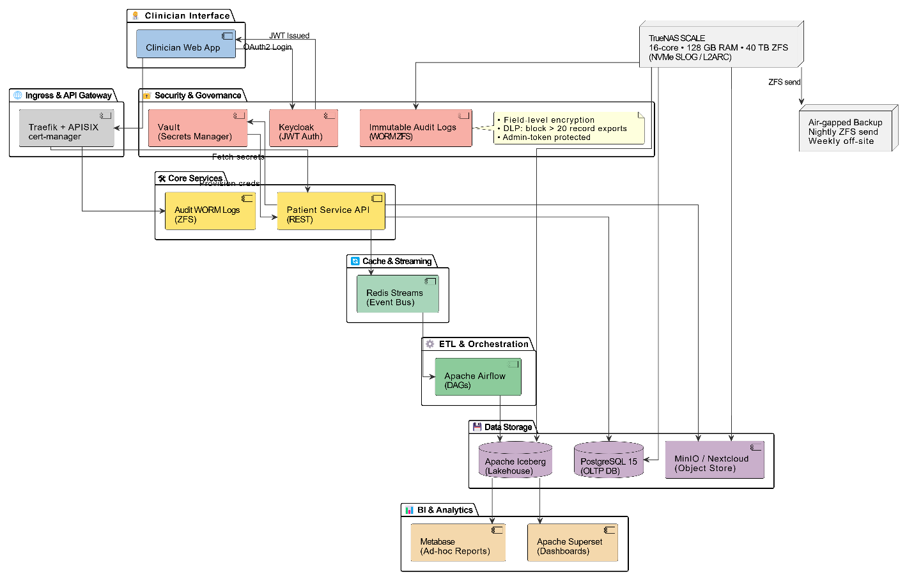
Fig. 4: Complete architecture
- Data Model Overview
Table | Key Fields | Notes
patient | id, mrn, name, dob, contact | MRN unique per clinic
encounter | id, patient_id, type, datetime, clinician_id | One row per visit
observation | id, encounter_id, code, value, unit | LOINC codes
invoice | id, encounter_id, amount, status | Linked to SHIF claim
file_object | uuid, s3_path, file_type, patient_id | MinIO bucket

- Security & Compliance
Medimesh embraces a defence‑in‑depth philosophy that knits together zero‑trust networking, strong encryption, tamper‑proof logging, and granular data‑loss‑prevention (DLP) policies—each mapped to the Kenya Data Protection Act 2019 and Health Insurance Portability and Accountability Act (HIPAA) technical safeguards.
- Zero‑trust perimeter with short‑lived credentials. No request is presumed trustworthy simply because it originates from the clinic network. All inbound traffic terminates at the API Gateway, which delegates authentication and authorisation to Keycloak, our open-source identity-and-access-management server. Keycloak mints JSON Web Tokens (JWTs)—digitally-signed, self-contained credentials that carry user roles and tenant identifiers—and sets their lifetime to just 15 minutes. If a token is intercepted, its utility window is small; yet single-sign-on flows ensure clinicians enjoy a frictionless experience.
- Field-level encryption for sensitive identifiers. Personally identifiable attributes such as National ID numbers, payment-card Primary Account Numbers, and passport details are encrypted within their respective database columns using deterministic Advanced Encryption Standard (AES-256-Galois/Counter Mode) keys held in HashiCorp Vault. The deterministic scheme preserves the ability to query—for instance, “find patient by National ID”—without exposing plaintext, and cryptographic key rotation is a single command that rewrites ciphertext in the background.
- Immutable audit logging on Write‑Once‑Read‑Many storage (WORM) ZFS dataset. Every create, read, update, delete, export, or authentication event is intercepted by a gRPC side-car and appended to an Audit table. A replication task streams these records to a dedicated Write-Once-Read-Many (WORM) dataset on Zettabyte File System (ZFS). Once committed, blocks become append-only; even a super-user cannot rewrite history, satisfying evidentiary requirements for malpractice litigation, insurance audits, and Ministry of Health inspections.
- Data‑loss‑prevention (DLP) rules: A policy engine embedded in the API Gateway tallies the number of distinct medical-record identifiers requested in any download. If the threshold exceeds twenty (20) records and the caller’s JWT lacks the privileged export.bulk scope, the request is denied and a real-time alert posts to the compliance channel in Mattermost. This thwarts both inadvertent “full database” exports and malicious data scrapes while still permitting routine single-patient transfers for referrals.
Together these layers ensure that even a successful breach of one component does not cascade into unrestricted access—protecting patient confidentiality, clinic reputation, and regulatory standing.

- Interoperability & Standards
- HL7 FHIR R5 resources exposed for external labs.
- OpenHIE compliant messaging planned (Phase II).
- ISO 13606 archetype mapping for future SHIF API.

- Implementation Roadmap
Phase | Duration | Deliverables
0. Planning | 4 wks | Signed SOW, privacy impact assessment
1. MVP Core | 8 wks | EHR, Auth, MinIO vault, RBAC
2. Pilot @ SN Karau | 4 wks | Data migration, staff training, go-live
3. Feedback & Hardening | 4 wks | Bug fixes, performance tuning
4. Multi-Clinic SaaS | 8 wks | Tenant isolation, subscription billing

- Roles & Responsibilities
To control development costs while safeguarding quality and security, Medimesh will be delivered by a compact five-person core team supplemented by a fractional infosec consultant. Each member carries cross-disciplinary duties so that no capability—especially cybersecurity—is left unattended.
Role | Primary Responsibilities | Cybersecurity Touchpoints
Product Owner — Richard K. | Defines product vision, prioritises backlog, approves releases, and champions user needs at SN Karau & future clinics. | Ensures security stories are prioritised; signs off on risk-based feature trade-offs.
Project Manager/Scrum-Master — Tiger (ChatGPT) | Creates and maintains sprint plans, tracks budget, resolves blockers, and reports to stakeholders. | Monitors vulnerability remediation progress as part of sprint metrics.
Lead Engineer (Full-stack + DevSecOps) | Owns system architecture, code reviews, CI/CD pipelines, container hardening, and on-call rotations. | Implements static/dynamic code scans, oversees patch management, responds to security incidents.
Data Architect & BI Specialist | Designs relational schema and Iceberg lakehouse, authors ETL jobs, optimises queries, and curates dashboards. | Ensures encryption-at-rest/on-wire for data stores, validates anonymisation in analytics exports.
Compliance & Security Officer (Part-time legal/infosec consultant) | Interprets Kenya DPA 2019, MOH EMR guidelines, and HIPAA; conducts threat modelling, privacy impact assessments, and external penetration tests twice a year. | Serves as single point of contact for the Office of the Data Protection Commissioner; approves Data Protection Impact Assessment (DPIA).
Clinic Champion — Dr Siboe | Provides clinical workflows, tests UX flows, drives staff adoption, and schedules training sessions. | Flags workflow gaps that could create unsafe shortcuts, ensuring secure yet usable design.
A fractional Infosec Consultant (engaged ~5 days/quarter) performs advanced tasks—penetration testing, Kubernetes benchmark audits, and incident-response tabletop drills—thereby giving the team senior security coverage without the cost of a full-time hire.

- Budget Estimate (KES)
Item | CapEx | OpEx / yr
Hardware (TrueNAS server) | 680,000 | —
Implementation services | 1,200,000 | —
Support & maintenance | — | 360,000
Training & change mgt. | 120,000 | 60,000
Total | ≈ 2. M | ≈ 0.42 M
(Detailed BOM in Appendix B)
- Risk & Mitigation
Risk | Likelihood | Impact | Mitigation
Staff resistance | Medium | High | Early UX demos, champions
Power outages | High | Medium | UPS + generator, ZFS journaling
Regulatory change | Low | Medium | Agile updates, modular API

- Next Steps
- Review & sign off proposal.
- Finalise hardware procurement.
- Schedule Phase 0 kick-off (target May 5 2025).

Appendix A — Architecture Diagram Source (draw.io)
(Use the existing XML attached in the Medimesh sub-room.)
Appendix B — Bill of Materials
- TrueNAS Mini XL+ chassis, 8 × 6 TB HDD, 2 × 1 TB NVMe (SLOG, L2ARC).
- 2 × 10 GbE NIC, 1 × 650 VA UPS.
- Spare parts kit (fans, drives).

